

**Amrita School of Computing**

23CSE113 – USER INTERFACE DESIGN

SIDDHARTH SASIKUMAR

CH.SC.U4CSE24145

**BACHELOR OF TECHNOLOGY**

IN

COMPUTER SCIENCE AND ENGINEERING

AMRITA VISHWA VIDYAPEETHAM

AMRITA SCHOOL OF COMPUTING

CHENNAI

**MOTO MAHALI WEBSITE**

**Introduction :**

**Moto Mahali** is a premium motorcycle dealership and lifestyle destination for bike enthusiasts. Known for offering top-tier bikes, expert service, and exceptional customer experiences, Moto Mahali brings the thrill of riding to life with a curated range of high-performance motorcycles and accessories. Whether you're a seasoned rider or a newcomer, Moto Mahali is your go-to hub for all things motorcycling.

**Aim :**

To build a website which displays motorcycles and different types of services offered by the company and make the website responsive.

**Software Requirements :**

VS code, Browser, Live server, Notepad.

**Index.html :**

**Code :**

<!DOCTYPE html>

<html lang="en">

<head>

  <meta charset="UTF-8" />

  <meta name="viewport" content="width=device-width, initial-scale=1.0"/>

  <title>MOTO MAHALI</title>

  <link rel="stylesheet" href="capstone.css" />

</head>

<body>

  <nav class="navbar">

    <div class="na">

      <ul>

        <li><img src="logo.jpg" style="width: 85px; height: 85px; border-radius: 40px;" /></li>

        <li><h2 class="name">MOTO MAHALI</h2></li>

      </ul>

    </div>

    <div class="hamburger" onclick="toggleMenu()">

      <div></div>

      <div></div>

      <div></div>

    </div>

    <div class="sidebar" id="navMenu">

      <ul>

        <li>

          <div class="dropdown">

            <button class="dropbtn">Motorcycles</button>

            <div class="dropdown-content">

              <a href="goldwing.html">Goldwing</a>

              <a href="cb650r.html">CBR 650R</a>

              <a href="cb350.html">CB350</a>

              <a href="transalp750.html">Transalp750</a>

            </div>

          </div>

        </li>

        <li><a href="ridesevent.html"><button>Rides & Events</button></a></li>

        <li><a href="service.html"><button>Services</button></a></li>

        <li><a href="about us.html"><button>Our Story</button></a></li>

      </ul>

    </div>

  </nav>

  <div class="welcome-container">

    <h2>🏍 Welcome to MOTO MAHALI! 🏍</h2>

    <p>Discover the thrill of two wheels with our premium range of motorcycles.</p>

    <p>From high-speed road machines to adventure-ready tourers, we bring you the best in performance and style.</p>

    <p>🚀 <strong>Expert Service & Support</strong> – Our skilled mechanics ensure your bike stays in peak condition.</p>

    <p>🎉 <strong>Exciting Rides & Events</strong> – Join our vibrant biking community for thrilling rides and events.</p>

    <p>⚙ <strong>Genuine Accessories & Gear</strong> – Find the perfect accessories to customize your ride.</p>

    <p>🔥 Whether you're a seasoned rider or just starting your journey, MOTO MAHALI is your ultimate biking destination.</p>

    <p><strong>Ride with passion. Ride with MOTO MAHALI.</strong></p>

  </div>

  <div class="footer"></div>

  <script>

    function toggleMenu() {

      const nav = document.getElementById("navMenu");

      nav.classList.toggle("active");

    }

    document.querySelectorAll(".sidebar a").forEach(link => {

      link.addEventListener("click", () => {

        document.getElementById("navMenu").classList.remove("active");

      });

    });

  </script>

</body>

</html>

**capstone.css : #used to style the index page**

**Code :**

/* === General === */

body {

    background-image: url(index_background.jpg);

    background-size: cover;

    background-position: center;

    background-attachment: fixed;

    margin: 0;

    padding: 0;

    font-family: Arial, sans-serif;

    min-height: 100vh;

    overflow-x: hidden;

}

/* === Navbar === */

.navbar {

    width: 100%;

    background-color: rgba(0, 0, 0, 0.9);

    color: rgb(255, 174, 0);

    display: flex;

    justify-content: space-between;

    align-items: center;

    padding: 10px 20px;

    position: fixed;

    top: 0;

    z-index: 1000;

    flex-wrap: wrap;

}

.na ul {

    list-style: none;

    display: flex;

    align-items: center;

    margin: 0;

    padding: 0;

    flex-wrap: wrap;

}

.na ul li {

    margin-right: 15px;

}

.na ul li img {

    width: 60px !important;

    height: 60px !important;

}

.name {

    color: white;

    font-size: 20px;

    margin-left: 10px;

}

/* === Buttons and Dropdown === */

button {

    background: none;

    border: none;

    color: white;

    font-size: 16px;

    cursor: pointer;

    padding: 8px 12px;

    transition: all 0.3s ease;

}

button:hover {

    background-color: rgba(255, 255, 255, 0.2);

    border-radius: 5px;

}

.dropbtn {

    background-color: #04AA6D;

    color: black;

    padding: 8px 12px;

    border: none;

    border-radius: 5px;

    font-size: 16px;

}

.dropdown {

    position: relative;

    display: inline-block;

}

.dropdown-content {

    display: none;

    position: absolute;

    background-color: #000000;

    min-width: 160px;

    z-index: 1;

    box-shadow: 0px 8px 16px rgba(0,0,0,0.3);

    border-radius: 5px;

}

.dropdown-content a {

    color: white;

    padding: 10px 15px;

    text-decoration: none;

    display: block;

    transition: background-color 0.3s;

}

.dropdown-content a:hover {

    background-color: #997708;

}

.dropdown:hover .dropdown-content {

    display: block;

}

.dropdown:hover .dropbtn {

    background-color: #bb8d0e;

}

a {

    text-decoration: none;

    color: white;

}

/* === Hamburger Menu === */

.hamburger {

    display: none;

    flex-direction: column;

    cursor: pointer;

    padding: 10px;

}

.hamburger div {

    width: 25px;

    height: 3px;

    background-color: white;

    margin: 4px 0;

    transition: all 0.3s ease;

}

/* === Sidebar === */

.sidebar {

    display: flex;

    align-items: center;

}

.sidebar ul {

    display: flex;

    list-style: none;

    margin: 0;

    padding: 0;

}

.sidebar ul li {

    margin: 0 10px;

}

/* === Welcome Section === */

.welcome-container {

    position: absolute;

    top: 50%;

    left: 50%;

    transform: translate(-50%, -50%);

    width: 90%;

    max-width: 700px;

    padding: 20px;

    background: rgba(255, 255, 255, 0.2);

    border-radius: 15px;

    backdrop-filter: blur(12px);

    text-align: center;

    color: black;

    font-size: 16px;

    font-weight: bold;

    box-shadow: 0 5px 15px rgba(0, 0, 0, 0.4);

    line-height: 1.5;

    opacity: 0;

    animation: slideDown 1.5s ease-out forwards;

    margin-top: 100px;

}

.welcome-container h2,

.welcome-container p {

    background: linear-gradient(to right, #ff7e5f, #feb47b, #86a8e7, #91eae4);

    -webkit-background-clip: text;

    -webkit-text-fill-color: transparent;

    margin: 10px 0;

}

.welcome-container h2 {

    font-size: 24px;

    margin-bottom: 15px;

}

.welcome-container p {

    font-size: 16px;

    text-align: left;

}

/* === Footer Placeholder === */

.footer {

    height: 100px;

    width: 100%;

}

/* === Animations === */

@keyframes slideDown {

    0% {

        top: -100px;

        opacity: 0;

    }

    100% {

        top: 50%;

        transform: translate(-50%, -50%);

        opacity: 1;

    }

}

/* === Responsive === */

@media (max-width: 768px) {

    .hamburger {

        display: flex;

    }

    .sidebar {

        display: none;

        width: 100%;

        background-color: rgba(0, 0, 0, 0.95);

        padding: 10px 0;

        flex-direction: column;

        position: absolute;

        top: 100%;

        left: 0;

    }

    .sidebar.active {

        display: flex;

    }

    .sidebar ul {

        flex-direction: column;

        width: 100%;

        align-items: center;

    }

    .sidebar ul li {

        margin: 10px 0;

        width: 100%;

        text-align: center;

    }

    .dropdown {

        width: 100%;

        text-align: center;

    }

    .dropdown-content {

        position: relative;

        width: 100%;

        box-shadow: none;

    }

    .na ul {

        flex-direction: row;

        align-items: center;

        justify-content: space-between;

        width: 100%;

    }

    .na .name {

        font-size: 18px;

    }

    .welcome-container {

        width: 90%;

        font-size: 14px;

        padding: 15px;

        margin-top: 80px;

    }

    .welcome-container h2 {

        font-size: 20px;

    }

    .welcome-container p {

        font-size: 14px;

    }

    .dropbtn, button {

        width: 100%;

        padding: 12px 0;

    }

}

@media (max-width: 480px) {

    .na ul li img {

        width: 50px !important;

        height: 50px !important;

    }

    .name {

        font-size: 16px;

    }

    .welcome-container {

        font-size: 13px;

        margin-top: 70px;

    }

    .welcome-container h2 {

        font-size: 18px;

    }

    .welcome-container p {

        font-size: 13px;

    }

}

**Cb 350.html:**

**Code :**

**!DOCTYPE html>**

**<html lang="en">**

**<head>**

**<meta charset="UTF-8" />**

**<meta name="viewport" content="width=device-width, initial-scale=1.0"/>**

**<title>Engine & Features Specifications</title>**

**<style>**

**body {**

**font-family: Arial, sans-serif;**

**background-color: #222;**

**color: white;**

**display: flex;**

**flex-direction: column;**

**align-items: center;**

**gap: 30px;**

**padding: 20px;**

**}**

**table {**

**width: 100%;**

**max-width: 800px;**

**border-collapse: collapse;**

**background-color: black;**

**color: white;**

**}**

**th, td {**

**border: 1px solid white;**

**padding: 10px;**

**text-align: left;**

**}**

**th {**

**background-color: gray;**

**text-align: center;**

**}**

**svg:hover {**

**cursor: pointer;**

**}**

**select {**

**background-color: black;**

**color: white;**

**padding: 10px;**

**border: 1px solid white;**

**font-size: 16px;**

**width: 100%;**

**max-width: 250px;**

**}**

**button:hover {**

**cursor: pointer;**

**opacity: 0.5;**

**transition: 0.5s;**

**}**

**.colors {**

**display: flex;**

**flex-wrap: wrap;**

**justify-content: center;**

**gap: 20px;**

**}**

**.colors div {**

**flex: 1 1 250px;**

**max-width: 300px;**

**}**

**.colors img {**

**width: 100%;**

**border-radius: 10px;**

**}**

**.booking {**

**display: flex;**

**flex-wrap: wrap;**

**justify-content: center;**

**gap: 20px;**

**width: 100%;**

**}**

**button {**

**border-radius: 5px;**

**background-color: rgb(238, 165, 70);**

**padding: 10px 20px;**

**color: black;**

**}**

**@media (max-width: 600px) {**

**body {**

**padding: 10px;**

**gap: 20px;**

**}**

**table, th, td {**

**font-size: 14px;**

**}**

**.colors div {**

**max-width: 100%;**

**}**

**select {**

**width: 100%;**

**}**

**.booking {**

**flex-direction: column;**

**align-items: center;**

**}**

**button {**

**width: 100%;**

**text-align: center;**

**}**

**img {**

**max-width: 100%;**

**}**

**}**

**</style>**

**</head>**

**<body>**

**<h2 style="text-align: center;">CB 350</h2>**

**<p style="text-align: center;">**

**The thunderous power, the fearless stance, the exhilarating rush of the open roads - a legend rises, CB350, where tech-meets-bold riding, with its timeless style and brave presence, itʼs your trusted sidekick.<br> Gear up to charge with the 2025-ready OBD-2B standards. Where others hesitate, you prefer exploring uncharted paths, you ride bolder together over every stretch of road with your CB350 as the ultimate ally,<br> subtly asserting your bold voice to the world of whisperers at every mile. So, it is your time to take the roads with CB350, Bold alone, Bolder together.**

**</p>**

**<img src="cb350.jpg" alt="CB350" style="width: 90%; max-width: 600px; border-radius: 2%;" />**

**<table>**

**<caption>ENGINE Specifications</caption>**

**<tr><td>Type</td><td>4 Stroke, SI Engine</td></tr>**

**<tr><td>Displacement</td><td>348.36cc</td></tr>**

**<tr><td>Max Engine Output</td><td>15.5kW @ 5500 rpm</td></tr>**

**<tr><td>Max Torque</td><td>29.4N-m @ 3000 rpm</td></tr>**

**<tr><td>Fuel System</td><td>PGM-FI</td></tr>**

**<tr><td>Bore x Stroke</td><td>70.000mm X 90.519mm</td></tr>**

**<tr><td>Compression Ratio</td><td>9.5:1</td></tr>**

**<tr><td>Starting Method</td><td>Self Start</td></tr>**

**</table>**

**<table>**

**<caption>MODELS</caption>**

**<tr>**

**<th>Features</th>**

**<th>DLX</th>**

**<th>DLX Pro</th>**

**</tr>**

**<tr><td>Honda Smartphone Voice Control System (HSVCS)</td><td>✗</td><td>✔</td></tr>**

**<tr><td>Headlight Cover</td><td>Silver</td><td>Chrome</td></tr>**

**<tr><td>Fender Color</td><td>Black</td><td>Body color</td></tr>**

**<tr><td>Seat Color</td><td>Black</td><td>Brown</td></tr>**

**</table>**

**<h2>Color options:</h2>**

**<div class="colors">**

**<div>**

**<img src="Mat_Crust_Metallic_dev1.png" alt="Sandstorm Color" />**

**<h3 style="text-align: center;">Sandstorm color</h3>**

**</div>**

**<div>**

**<img src="Mat_Marshal_Green_Metallic_dev1.png" alt="Green Color" />**

**<h3 style="text-align: center;">Green color</h3>**

**</div>**

**<div>**

**<img src="Precious_Red_Metallic_dev1.png" alt="Red Color" />**

**<h3 style="text-align: center;">Red color</h3>**

**</div>**

**</div>**

**<h2 style="text-align: center;">Ex-Showroom Price Rs.1,99,990</h2>**

**<div class="booking">**

**<div>**

**<select>**

**<option selected disabled>SELECT STATE</option>**

**<!-- States... -->**

**<option value="Andhra Pradesh">Andhra Pradesh</option>**

**<option value="Telangana">Telangana</option>**

**<option value="Tamil Nadu">Tamil Nadu</option>**

**<!-- add more states as needed -->**

**</select>**

**</div>**

**<div>**

**<a href="testrideform.html">**

**<button><h3>Book Test Ride</h3></button>**

**</a>**

**</div>**

**</div>**

**<a href="form.html">**

**<button><h2>BOOK NOW</h2></button>**

**</a>**

**</body>**

**</html>**

**CB 650r.html:**

**<!DOCTYPE html>**

**<html lang="en">**

**<head>**

**<meta charset="UTF-8" />**

**<meta name="viewport" content="width=device-width, initial-scale=1.0"/>**

**<title>Engine & Features Specifications</title>**

**<style>**

**body {**

**font-family: Arial, sans-serif;**

**background-color: #222;**

**color: white;**

**display: flex;**

**flex-direction: column;**

**align-items: center;**

**gap: 30px;**

**padding: 20px;**

**overflow-x: hidden;**

**}**

**img {**

**max-width: 100%;**

**height: auto;**

**border-radius: 2%;**

**}**

**table {**

**width: 100%;**

**max-width: 700px;**

**border-collapse: collapse;**

**background-color: black;**

**color: white;**

**}**

**th, td {**

**border: 1px solid white;**

**padding: 10px;**

**text-align: left;**

**}**

**th {**

**background-color: gray;**

**text-align: center;**

**}**

**select {**

**background-color: black;**

**color: white;**

**padding: 10px;**

**border: 1px solid white;**

**font-size: 16px;**

**width: 250px;**

**}**

**button:hover {**

**cursor: pointer;**

**opacity: 0.5;**

**transition: 0.5s;**

**}**

**.colornames {**

**display: flex;**

**gap: 20px;**

**justify-content: center;**

**flex-wrap: wrap;**

**}**

**.booking {**

**display: flex;**

**gap: 10px;**

**flex-wrap: wrap;**

**justify-content: center;**

**}**

**a button {**

**border-radius: 5px;**

**background-color: rgb(238, 165, 70);**

**width: auto;**

**height: auto;**

**padding: 10px 20px;**

**color: black;**

**}**

**@media (max-width: 768px) {**

**table, select {**

**font-size: 14px;**

**}**

**.colornames img {**

**width: 100%;**

**height: auto;**

**max-width: 300px;**

**}**

**h2, h3 {**

**text-align: center;**

**font-size: 1.5rem;**

**}**

**.booking {**

**flex-direction: column;**

**align-items: center;**

**}**

**}**

**</style>**

**</head>**

**<body>**

**<h2>CBR 650R</h2>**

**<p>**

**The CBR650R is the perfect blend of form and function. With its powerful inline-four engine, razor-sharp handling, and eye-catching design, this bike provides an unrivalled precision riding experience. Take control of your daily commute with speed and style.<br><br>**

**The bike is both purposeful and elegant, with an overhauled design ideal for everything from weekday commuting to weekend getaways, flawlessly blending comfort and cool. Style has been aggressively redesigned, drawing inspiration from the legendary CBR1000RR-R Fireblade.**

**</p>**

**<img src="cbr650r.jpg" alt="CBR 650R">**

**<table>**

**<caption>Engine Specifications</caption>**

**<tr><td>Engine Type</td><td>4 stroke 16 valve DOHC, inline 4, liquid-cooled</td></tr>**

**<tr><td>Engine Displacement</td><td>649 cc</td></tr>**

**<tr><td>Max. Power Output</td><td>70 kW @ 12,000 rpm</td></tr>**

**<tr><td>Max. Torque</td><td>63 N-m @ 9,500 rpm</td></tr>**

**<tr><td>Compression Ratio</td><td>11.6:1</td></tr>**

**<tr><td>Bore & Stroke</td><td>67 x 46 mm</td></tr>**

**<tr><td>Starter</td><td>Electric</td></tr>**

**<tr><td>Fuel System</td><td>Fuel Injection</td></tr>**

**<tr><td>Fuel Capacity</td><td>15.4 L</td></tr>**

**</table>**

**<table>**

**<caption>Tyres & Brakes</caption>**

**<tr><td>Tyres (Front)</td><td>120/70-17 M/C</td></tr>**

**<tr><td>Tyres (Rear)</td><td>180/55-17 M/C</td></tr>**

**<tr><td>Suspension Front</td><td>Showa SFF USD fork</td></tr>**

**<tr><td>Suspension Rear</td><td>Monoshock damper with 10-stage pre-load adjuster</td></tr>**

**<tr><td>Brakes (Front)</td><td>310 mm x 4.5 mm double disc with 4-piston caliper</td></tr>**

**<tr><td>Brakes (Rear)</td><td>240 mm x 5 mm single disc with single piston caliper</td></tr>**

**</table>**

**<h2>Color options:</h2>**

**<div class="colornames">**

**<div>**

**<img src="GRAND-PRIX-RED-24.png" alt="Grand Prix Red">**

**<h3 style="text-align:center;">Grand Prix Red</h3>**

**</div>**

**<div>**

**<img src="Mat-Ballistic-Black-Metallic-24.png" alt="Mat Black">**

**<h3 style="text-align:center;">Mat Ballistic Black</h3>**

**</div>**

**</div>**

**<h2>Ex-Showroom Price Rs.9,16,055</h2>**

**<div class="booking">**

**<div>**

**<select>**

**<option selected disabled>SELECT STATE</option>**

**<option value="Andhra Pradesh">Andhra Pradesh</option>**

**<option value="Arunachal Pradesh">Arunachal Pradesh</option>**

**<option value="Assam">Assam</option>**

**<option value="Bihar">Bihar</option>**

**<option value="Chhattisgarh">Chhattisgarh</option>**

**<option value="Goa">Goa</option>**

**<option value="Gujarat">Gujarat</option>**

**<option value="Haryana">Haryana</option>**

**<option value="Himachal Pradesh">Himachal Pradesh</option>**

**<option value="Jharkhand">Jharkhand</option>**

**<option value="Karnataka">Karnataka</option>**

**<option value="Kerala">Kerala</option>**

**<option value="Madhya Pradesh">Madhya Pradesh</option>**

**<option value="Maharashtra">Maharashtra</option>**

**<option value="Manipur">Manipur</option>**

**<option value="Meghalaya">Meghalaya</option>**

**<option value="Mizoram">Mizoram</option>**

**<option value="Nagaland">Nagaland</option>**

**<option value="Odisha">Odisha</option>**

**<option value="Punjab">Punjab</option>**

**<option value="Rajasthan">Rajasthan</option>**

**<option value="Sikkim">Sikkim</option>**

**<option value="Tamil Nadu">Tamil Nadu</option>**

**<option value="Telangana">Telangana</option>**

**<option value="Tripura">Tripura</option>**

**<option value="Uttar Pradesh">Uttar Pradesh</option>**

**<option value="Uttarakhand">Uttarakhand</option>**

**<option value="West Bengal">West Bengal</option>**

**</select>**

**</div>**

**<div>**

**<a href="testrideform.html">**

**<button><h3>Book Test Ride</h3></button>**

**</a>**

**</div>**

**</div>**

**<a href="form.html">**

**<button><h2>BOOK NOW</h2></button>**

**</a>**

**</body>**

**</html>**

**Transalp750.html:**

**<!DOCTYPE html>**

**<html lang="en">**

**<head>**

**<meta charset="UTF-8" />**

**<meta name="viewport" content="width=device-width, initial-scale=1.0"/>**

**<title>Transalp 750 - Specifications</title>**

**<style>**

**body {**

**font-family: Arial, sans-serif;**

**background-color: #222;**

**color: white;**

**display: flex;**

**flex-direction: column;**

**align-items: center;**

**gap: 30px;**

**padding: 20px;**

**overflow-x: hidden;**

**}**

**table {**

**width: 70%;**

**border-collapse: collapse;**

**background-color: black;**

**color: white;**

**}**

**th, td {**

**border: 1px solid white;**

**padding: 10px;**

**text-align: left;**

**}**

**th {**

**background-color: gray;**

**text-align: center;**

**}**

**select {**

**background-color: black;**

**color: white;**

**padding: 10px;**

**border: 1px solid white;**

**font-size: 16px;**

**width: 250px;**

**}**

**button:hover {**

**cursor: pointer;**

**opacity: 0.5;**

**transition: 0.5s;**

**}**

**img {**

**max-width: 100%;**

**height: auto;**

**border-radius: 2%;**

**}**

**.colornames {**

**display: flex;**

**gap: 40px;**

**justify-content: center;**

**flex-wrap: wrap;**

**}**

**.booking {**

**display: flex;**

**gap: 20px;**

**justify-content: center;**

**flex-wrap: wrap;**

**}**

**button {**

**border-radius: 5px;**

**background-color: rgb(238, 165, 70);**

**padding: 10px 20px;**

**border: none;**

**color: black;**

**}**

**h2, h3 {**

**text-align: center;**

**}**

**</style>**

**</head>**

**<body>**

**<h2>Transalp 750</h2>**

**<p>**

**The XL750 TRANSALP is meticulously crafted to deliver unparalleled touring performance, ensuring comfort during every leg of your journey. Whether you're navigating the bustling city streets, conquering the open highway, or venturing onto rugged mountain paths, this all-rounder touring companion has been reborn to accompany you wherever your journeys may take you.**

**<br><br>**

**Its design exudes purpose and resilience, boasting a sleek and tough appearance. Whether you find yourself in the midst of urban sprawl, embarking on epic highway expeditions, or exploring endless off-road trails, the slender profile of the mid-section, combined with its aerodynamic fairing, gives you freedom with wind protection.**

**</p>**

**<img src="transalp750.jpg" alt="Transalp 750">**

**<table>**

**<caption><h3>Engine Specifications</h3></caption>**

**<tr><td>Type</td><td>OHC (Uni-cam) liquid-cooled inline two-cylinder</td></tr>**

**<tr><td>Displacement</td><td>755cc</td></tr>**

**<tr><td>Max Power</td><td>67.5kW @ 9500rpm</td></tr>**

**<tr><td>Max Torque</td><td>75N-m @ 7250 rpm</td></tr>**

**<tr><td>Fuel System</td><td>Fuel Injection</td></tr>**

**<tr><td>Bore x Stroke</td><td>87.0 x 63.5</td></tr>**

**<tr><td>Compression Ratio</td><td>11.0:2</td></tr>**

**<tr><td>Valve System</td><td>8 Valve</td></tr>**

**<tr><td>No. of Cylinders</td><td>2</td></tr>**

**</table>**

**<h2>Color Options</h2>**

**<div class="colornames">**

**<div>**

**<img src="Ross_White_dev2.png" alt="Ross White">**

**</div>**

**<div>**

**<img src="Matte_Ballistic_Black_Metallic_dev2.png" alt="Matte Ballistic Black">**

**</div>**

**</div>**

**<h2>Ex-Showroom Price: ₹11,16,005</h2>**

**<div class="booking">**

**<div>**

**<select>**

**<option selected disabled>SELECT STATE</option>**

**<option value="Andhra Pradesh">Andhra Pradesh</option>**

**<option value="Arunachal Pradesh">Arunachal Pradesh</option>**

**<option value="Assam">Assam</option>**

**<option value="Bihar">Bihar</option>**

**<option value="Chhattisgarh">Chhattisgarh</option>**

**<option value="Goa">Goa</option>**

**<option value="Gujarat">Gujarat</option>**

**<option value="Haryana">Haryana</option>**

**<option value="Himachal Pradesh">Himachal Pradesh</option>**

**<option value="Jharkhand">Jharkhand</option>**

**<option value="Karnataka">Karnataka</option>**

**<option value="Kerala">Kerala</option>**

**<option value="Madhya Pradesh">Madhya Pradesh</option>**

**<option value="Maharashtra">Maharashtra</option>**

**<option value="Manipur">Manipur</option>**

**<option value="Meghalaya">Meghalaya</option>**

**<option value="Mizoram">Mizoram</option>**

**<option value="Nagaland">Nagaland</option>**

**<option value="Odisha">Odisha</option>**

**<option value="Punjab">Punjab</option>**

**<option value="Rajasthan">Rajasthan</option>**

**<option value="Sikkim">Sikkim</option>**

**<option value="Tamil Nadu">Tamil Nadu</option>**

**<option value="Telangana">Telangana</option>**

**<option value="Tripura">Tripura</option>**

**<option value="Uttar Pradesh">Uttar Pradesh</option>**

**<option value="Uttarakhand">Uttarakhand</option>**

**<option value="West Bengal">West Bengal</option>**

**</select>**

**</div>**

**<div>**

**<a href="testrideform.html">**

**<button><h3>Book Test Ride</h3></button>**

**</a>**

**</div>**

**</div>**

**<a href="form.html">**

**<button><h2>BOOK NOW</h2></button>**

**</a>**

**</body>**

**</html>**

**Goldwing.html:**

**<!DOCTYPE html>**

**<html lang="en">**

**<head>**

**<meta charset="UTF-8" />**

**<meta name="viewport" content="width=device-width, initial-scale=1.0"/>**

**<title>Engine & Features Specifications</title>**

**<style>**

**body {**

**font-family: Arial, sans-serif;**

**background-color: #222;**

**color: white;**

**display: flex;**

**flex-direction: column;**

**align-items: center;**

**gap: 20px;**

**padding: 20px;**

**margin: 0;**

**}**

**h2, h3, p {**

**text-align: center;**

**padding: 0 10px;**

**}**

**img {**

**max-width: 90%;**

**height: auto;**

**border-radius: 2%;**

**}**

**table {**

**width: 95%;**

**max-width: 800px;**

**border-collapse: collapse;**

**background-color: black;**

**color: white;**

**margin: 0 auto;**

**}**

**th, td {**

**border: 1px solid white;**

**padding: 10px;**

**text-align: left;**

**}**

**th {**

**background-color: gray;**

**text-align: center;**

**}**

**select {**

**background-color: black;**

**color: white;**

**padding: 10px;**

**border: 1px solid white;**

**font-size: 16px;**

**width: 100%;**

**max-width: 250px;**

**box-sizing: border-box;**

**}**

**button {**

**border-radius: 5px;**

**background-color: rgb(238, 165, 70);**

**color: black;**

**padding: 10px 20px;**

**border: none;**

**font-size: 1rem;**

**transition: 0.5s;**

**}**

**button:hover {**

**cursor: pointer;**

**opacity: 0.7;**

**}**

**.colornames {**

**width: 100%;**

**display: flex;**

**flex-direction: column;**

**align-items: center;**

**}**

**.booking {**

**display: flex;**

**flex-direction: column;**

**align-items: center;**

**gap: 15px;**

**width: 100%;**

**}**

**@media (min-width: 600px) {**

**.booking {**

**flex-direction: row;**

**justify-content: center;**

**}**

**.colornames img {**

**margin-left: 0;**

**width: 40%;**

**}**

**}**

**</style>**

**</head>**

**<body>**

**<h2>THE GOLDWING TOUR</h2>**

**<p>**

**The Gold Wing Tour is a Honda flagship motorcycle for a reason, offering supreme levels of performance and luxury through the city, or out on the open road. Taking the incredible Gold Wing as a base, it adds carrying capacity and a more comfortable and relaxed ride for the pillion. Luxurious material features on both front and rear seats – ensuring ultimate riding comfort. The audio system and speakers deliver crisp sound quality, whilst dual LED fog lights guarantee piercing visibility.**

**</p>**

**<img src="goldwing.jpg" alt="Goldwing Motorcycle"/>**

**<table>**

**<caption>Engine Specification</caption>**

**<tr><td>Type</td><td>Liquid-cooled 4 Stroke 24 valve SOHC Flat-6</td></tr>**

**<tr><td>Displacement</td><td>1,833cc</td></tr>**

**<tr><td>Valves per Cylinder</td><td>4</td></tr>**

**<tr><td>Bore x Stroke</td><td>73mm x 73mm</td></tr>**

**<tr><td>Compression Ratio</td><td>10.5:1</td></tr>**

**<tr><td>Max. Power Output</td><td>93KW/5500rpm</td></tr>**

**<tr><td>Max. Torque</td><td>170Nm/4500rpm</td></tr>**

**<tr><td>Oil Capacity</td><td>5.6L (DCT)</td></tr>**

**<tr><td>CO² Emissions</td><td>127g/km</td></tr>**

**</table>**

**<table>**

**<caption>Drivetrain</caption>**

**<tr><td>Clutch Type</td><td>(DCT) Hydraulic, wet, multiplate with oil pressure</td></tr>**

**<tr><td>Transmission Type</td><td>7-speed forward and reverse DCT</td></tr>**

**<tr><td>Primary Reduction</td><td>1.795 (79/44)</td></tr>**

**<tr><td>Gear Ratios</td><td>(DCT) 1st: 2.167 2nd: 1.696 3rd: 1.304 4th: 1.038 5th: 0.821 6th: 0.667 7th: 0.522 Rev: 1.190</td></tr>**

**<tr><td>Final Reduction</td><td>Engine side 0.972 <br> Rear Wheel side 2.615</td></tr>**

**<tr><td>Final Drive</td><td>Enclose Shaft</td></tr>**

**</table>**

**<table>**

**<caption>Fuel Type</caption>**

**<tr><td>Carburettor</td><td>PGM-FI Electronic Fuel Injection</td></tr>**

**<tr><td>Throttle Bore</td><td>50mm</td></tr>**

**<tr><td>Air Cleaner</td><td>Viscous, cartridge type paper filter</td></tr>**

**<tr><td>Fuel Tank Capacity</td><td>21.1L</td></tr>**

**</table>**

**<h2>Color options:</h2>**

**<div class="colornames">**

**<img src="PEARL_GLARE_WHITE.png" alt="Pearl Glare White">**

**<h3>Pearl White</h3>**

**<h2>Ex-Showroom Price Rs.39,16,055</h2>**

**</div>**

**<div class="booking">**

**<select>**

**<option selected disabled>SELECT STATE</option>**

**<option value="Andhra Pradesh">Andhra Pradesh</option>**

**<option value="Arunachal Pradesh">Arunachal Pradesh</option>**

**<option value="Assam">Assam</option>**

**<option value="Bihar">Bihar</option>**

**<option value="Chhattisgarh">Chhattisgarh</option>**

**<option value="Goa">Goa</option>**

**<option value="Gujarat">Gujarat</option>**

**<option value="Haryana">Haryana</option>**

**<option value="Himachal Pradesh">Himachal Pradesh</option>**

**<option value="Jharkhand">Jharkhand</option>**

**<option value="Karnataka">Karnataka</option>**

**<option value="Kerala">Kerala</option>**

**<option value="Madhya Pradesh">Madhya Pradesh</option>**

**<option value="Maharashtra">Maharashtra</option>**

**<option value="Manipur">Manipur</option>**

**<option value="Meghalaya">Meghalaya</option>**

**<option value="Mizoram">Mizoram</option>**

**<option value="Nagaland">Nagaland</option>**

**<option value="Odisha">Odisha</option>**

**<option value="Punjab">Punjab</option>**

**<option value="Rajasthan">Rajasthan</option>**

**<option value="Sikkim">Sikkim</option>**

**<option value="Tamil Nadu">Tamil Nadu</option>**

**<option value="Telangana">Telangana</option>**

**<option value="Tripura">Tripura</option>**

**<option value="Uttar Pradesh">Uttar Pradesh</option>**

**<option value="Uttarakhand">Uttarakhand</option>**

**<option value="West Bengal">West Bengal</option>**

**</select>**

**<a href="testrideform.html">**

**<button><h3>Book Test Ride</h3></button>**

**</a>**

**</div>**

**<a href="form.html">**

**<button><h2>BOOK NOW</h2></button>**

**</a>**

**</body>**

**</html>**

**Service.html:**

**<!DOCTYPE html>**

**<html lang="en">**

**<head>**

**<meta charset="UTF-8">**

**<meta name="viewport" content="width=device-width, initial-scale=1.0">**

**<title>Menu</title>**

**<style>**

**body {**

**display: flex;**

**flex-direction: column;**

**justify-content: center;**

**align-items: center;**

**min-height: 100vh;**

**background-color: black;**

**color: white;**

**font-family: Arial, sans-serif;**

**padding: 20px;**

**box-sizing: border-box;**

**text-align: center;**

**}**

**.menu {**

**display: flex;**

**flex-direction: column;**

**align-items: center;**

**gap: 20px;**

**width: 100%;**

**max-width: 400px;**

**}**

**.menu button {**

**width: 100%;**

**max-width: 300px;**

**height: 60px;**

**display: flex;**

**align-items: center;**

**justify-content: space-between;**

**padding: 10px 15px;**

**font-size: 16px;**

**border: none;**

**border-radius: 5px;**

**background: rgb(255, 0, 0);**

**color: rgb(255, 255, 255);**

**cursor: pointer;**

**transition: background 0.3s, color 0.3s;**

**}**

**.menu button:hover {**

**background: rgb(255, 255, 255);**

**color: rgb(255, 0, 0);**

**}**

**.menu svg {**

**width: 32px;**

**height: 32px;**

**}**

**a {**

**text-decoration: none;**

**width: 100%;**

**}**

**button {**

**margin: 20px auto;**

**}**

**@media (max-width: 480px) {**

**.menu button {**

**flex-direction: column;**

**align-items: center;**

**justify-content: center;**

**gap: 10px;**

**font-size: 14px;**

**}**

**.menu svg {**

**width: 24px;**

**height: 24px;**

**}**

**}**

**</style>**

**</head>**

**<body>**

**<center>**

**<h1>What type of service you are looking for!</h1><br>**

**<div class="menu">**

**<a href="cancellation.html">**

**<button>Booking Cancellation**

**<svg width="32" height="32" viewBox="0 0 32 32">**

**<path d="M6 14l2-4h16l2 4v10h-2v-2H8v2H6V14z" fill="#ccc"/>**

**<path d="M10 14h4v4h-4zM18 14h4v4h-4z" fill="#eee"/>**

**<circle cx="10" cy="24" r="3" fill="#555"/>**

**<circle cx="22" cy="24" r="3" fill="#555"/>**

**<line x1="4" y1="4" x2="28" y2="28" stroke="red" stroke-width="4" stroke-linecap="round"/>**

**</svg>**

**</button>**

**</a>**

**<a href="refundform.html">**

**<button>Apply Refund**

**<svg width="32" height="32" viewBox="0 0 300 150">**

**<rect x="10" y="10" width="280" height="130" rx="20" ry="20" fill="#4CAF50" stroke="#2E7D32" stroke-width="4"/>**

**<ellipse cx="50" cy="75" rx="30" ry="40" fill="#388E3C"/>**

**<ellipse cx="250" cy="75" rx="30" ry="40" fill="#388E3C"/>**

**<circle cx="150" cy="75" r="40" fill="#FFFFFF" stroke="#2E7D32" stroke-width="3"/>**

**<text x="135" y="90" font-size="40" font-weight="bold" fill="#2E7D32">$</text>**

**</svg>**

**</button>**

**</a>**

**<a href="rcform.html">**

**<button>Get RSA**

**<svg width="32" height="32" viewBox="0 0 100 100">**

**<rect x="20" y="10" width="60" height="80" rx="5" ry="5" fill="#F5F5F5" stroke="#000" stroke-width="3"/>**

**<line x1="30" y1="30" x2="70" y2="30" stroke="#000" stroke-width="2"/>**

**<line x1="30" y1="40" x2="70" y2="40" stroke="#000" stroke-width="2"/>**

**<line x1="30" y1="50" x2="70" y2="50" stroke="#000" stroke-width="2"/>**

**<line x1="30" y1="60" x2="50" y2="60" stroke="#000" stroke-width="2"/>**

**<polygon points="60,70 80,90 85,85 65,65" fill="#000"/>**

**<rect x="65" y="65" width="5" height="20" fill="#666" stroke="#000" stroke-width="2"/>**

**<polygon points="80,90 85,85 88,88 83,93" fill="#000"/>**

**</svg>**

**</button>**

**</a>**

**<a href="serviceform.html">**

**<button>Vehicle Service**

**<svg width="32" height="32" viewBox="0 0 100 100">**

**<circle cx="50" cy="50" r="20" stroke="#000" stroke-width="4" fill="none"/>**

**<circle cx="50" cy="50" r="8" fill="#000"/>**

**<rect x="48" y="28" width="4" height="10" fill="#000"/>**

**<rect x="48" y="62" width="4" height="10" fill="#000"/>**

**<rect x="28" y="48" width="10" height="4" fill="#000"/>**

**<rect x="62" y="48" width="10" height="4" fill="#000"/>**

**<rect x="35" y="35" width="8" height="4" transform="rotate(-45 35 35)" fill="#000"/>**

**<rect x="57" y="35" width="8" height="4" transform="rotate(45 57 35)" fill="#000"/>**

**<rect x="35" y="57" width="8" height="4" transform="rotate(45 35 57)" fill="#000"/>**

**<rect x="57" y="57" width="8" height="4" transform="rotate(-45 57 57)" fill="#000"/>**

**</svg>**

**</button>**

**</a>**

**</div>**

**<div>**

**<h3>For emergency contact "99XXXXXXXX" or mail us at "MotoMahali@YYY.com"</h3>**

**</div>**

**</center>**

**</body>**

**</html>**

**Rcform.html:**

**<!DOCTYPE html>**

**<html lang="en">**

**<head>**

**<meta charset="UTF-8">**

**<meta name="viewport" content="width=device-width, initial-scale=1.0">**

**<title>Vehicle RC Upload</title>**

**<style>**

**body {**

**display: flex;**

**justify-content: center;**

**align-items: center;**

**height: 100vh;**

**background-color: black;**

**color: white;**

**font-family: Arial, sans-serif;**

**}**

**form {**

**background: linear-gradient(to right, #ff7e5f, #feb47b, #86a8e7, #91eae4);**

**padding: 20px;**

**border-radius: 8px;**

**color: black;**

**width: 300px;**

**}**

**input, button {**

**width: 95%;**

**padding: 10px;**

**margin: 10px 0;**

**border: 1px solid #ccc;**

**border-radius: 5px;**

**}**

**button {**

**background-color: #28a745;**

**color: white;**

**cursor: pointer;**

**}**

**</style>**

**</head>**

**<body>**

**<form id="vehicleForm">**

**<h2>Upload Vehicle RC</h2>**

**<label for="name">Name:</label>**

**<input type="text" id="name" name="name" required>**

**<label for="email">Email:</label>**

**<input type="email" id="email" name="email" required>**

**<label for="phone">Phone Number:</label>**

**<input type="tel" id="phone" name="phone" pattern="\d{10}" required>**

**<label for="file">Upload RC:</label>**

**<input type="file" id="file" name="file" required>**

**<button type="submit">Submit</button>**

**</form>**

**<script>**

**document.getElementById("bikeServiceForm").addEventListener("submit", function(event) {**

**event.preventDefault();**

**let name = document.getElementById("name").value.trim();**

**let phone = document.getElementById("phone").value.trim();**

**let email = document.getElementById("email").value.trim();**

**let bikeModel = document.getElementById("bikeModel").value.trim();**

**let serviceDate = document.getElementById("serviceDate").value;**

**let serviceType = document.getElementById("serviceType").value;**

**let file = document.getElementById("file").files.length;**

**if (name === "") {**

**alert("Please enter your name.");**

**return;**

**}**

**if (!/^\d{10}$/.test(phone)) {**

**alert("Please enter a valid 10-digit phone number.");**

**return;**

**}**

**if (!/^[^\s@]+@[^\s@]+\.[^\s@]+$/.test(email)) {**

**alert("Please enter a valid email address.");**

**return;**

**}**

**if (file === 0) {**

**alert("Please upload your driving license.");**

**return;**

**}**

**alert("out team will contact you shortly");**

**this.submit();**

**});**

**</script>**

**Refundform.html:**

**<!DOCTYPE html>**

**<html lang="en">**

**<head>**

**<meta charset="UTF-8">**

**<meta name="viewport" content="width=device-width, initial-scale=1.0">**

**<title>Fee Refund Form</title>**

**<style>**

**body {**

**display: flex;**

**justify-content: center;**

**align-items: center;**

**height: 100vh;**

**background-color: black;**

**color: white;**

**font-family: Arial, sans-serif;**

**}**

**form {**

**background: linear-gradient(to right, #ff7e5f, #feb47b, #86a8e7, #91eae4);**

**padding: 20px;**

**border-radius: 8px;**

**color: black;**

**width: 300px;**

**}**

**input, textarea, button {**

**width: 95%;**

**padding: 10px;**

**margin: 10px 0;**

**border: 1px solid #ccc;**

**border-radius: 5px;**

**}**

**textarea {**

**height: 80px;**

**resize: none;**

**}**

**button {**

**background-color: #28a745;**

**color: white;**

**cursor: pointer;**

**}**

**</style>**

**</head>**

**<body>**

**<form id="refundForm">**

**<center><h2>Fee Refund Form</h2><center>**

**<label for="name">Name:</label>**

**<input type="text" id="name" name="name" required>**

**<label for="phone">Phone Number:</label>**

**<input type="tel" id="phone" name="phone" pattern="\d{10}" required>**

**<label for="bookingNumber">Booking Number:</label>**

**<input type="text" id="bookingNumber" name="bookingNumber" required>**

**<label for="reason">Refund Reason:</label>**

**<textarea id="reason" name="reason" required></textarea>**

**<label for="file">Upload Invoice:</label>**

**<input type="file" id="file" name="file" required>**

**<button type="submit">Submit</button>**

**</form>**

**<script>**

**document.getElementById('refundForm').addEventListener('submit', function(event) {**

**event.preventDefault();**

**let name = document.getElementById('name').value.trim();**

**let phone = document.getElementById('phone').value.trim();**

**let bookingNumber = document.getElementById('bookingNumber').value.trim();**

**let reason = document.getElementById('reason').value.trim();**

**let file = document.getElementById('file').value.trim();**

**if (name === '' || phone === '' || bookingNumber === '' || reason === '' || file === '') {**

**alert('All fields are required!');**

**return;**

**}**

**let phonePattern = /^\d{10}$/;**

**if (!phonePattern.test(phone)) {**

**alert('Enter a valid 10-digit phone number');**

**return;**

**}**

**alert('Refund request submitted successfully!');**

**});**

**</script>**

**</body>**

**</html>**

**Ridesevent.html:**

**<!DOCTYPE html>**

**<html lang="en">**

**<head>**

**<meta charset="UTF-8" />**

**<meta name="viewport" content="width=device-width, initial-scale=1.0"/>**

**<title>Bike Rides & Events</title>**

**<style>**

**body {**

**background-color: black;**

**color: white;**

**font-family: Arial, sans-serif;**

**margin: 0;**

**padding: 0;**

**text-align: center;**

**}**

**.container {**

**width: 90%;**

**max-width: 1000px;**

**margin: auto;**

**padding: 20px;**

**}**

**h1 {**

**font-size: 2.5rem;**

**margin-bottom: 30px;**

**}**

**.event {**

**background: linear-gradient(to right, #ff7e5f, #feb47b);**

**padding: 20px;**

**border-radius: 10px;**

**margin: 30px 0;**

**color: black;**

**box-shadow: 0 0 10px rgba(255, 255, 255, 0.1);**

**}**

**.event h2 {**

**font-size: 1.8rem;**

**}**

**.event p {**

**font-size: 1rem;**

**}**

**img {**

**width: 100%;**

**max-width: 600px;**

**height: auto;**

**border-radius: 10px;**

**margin: 15px 0;**

**}**

**.contact {**

**font-size: 1.2rem;**

**margin-top: 40px;**

**color: #ffb;**

**}**

**@media (max-width: 768px) {**

**h1 {**

**font-size: 2rem;**

**}**

**.event h2 {**

**font-size: 1.5rem;**

**}**

**.event p {**

**font-size: 0.95rem;**

**}**

**.contact {**

**font-size: 1rem;**

**padding: 0 10px;**

**}**

**}**

**@media (max-width: 480px) {**

**.container {**

**padding: 10px;**

**}**

**h1 {**

**font-size: 1.7rem;**

**}**

**.event h2 {**

**font-size: 1.3rem;**

**}**

**.event p {**

**font-size: 0.9rem;**

**}**

**img {**

**width: 100%;**

**}**

**}**

**</style>**

**</head>**

**<body>**

**<div class="container">**

**<h1>Upcoming Bike Rides & Events</h1>**

**<div class="event">**

**<h2>Mountain Adventure Ride</h2>**

**<img src="mountainbike.jpg" alt="Mountain Adventure Ride">**

**<p><strong>Date:</strong> 15th April 2025</p>**

**<p><strong>Venue:</strong> Manali, Himachal Pradesh</p>**

**<p>Join us for an exhilarating mountain bike ride through scenic trails. Experience nature like never before!</p>**

**</div>**

**<div class="event">**

**<h2>City Night Ride</h2>**

**<img src="citynight.jpg" alt="City Night Ride">**

**<p><strong>Date:</strong> 30th May 2025</p>**

**<p><strong>Venue:</strong> Marine Drive, Mumbai</p>**

**<p>Ride through the city's illuminated streets with fellow bikers. A great way to enjoy the nightlife on two wheels!</p>**

**</div>**

**<div class="event">**

**<h2>Annual Bike Marathon</h2>**

**<img src="bikemarathon.jpg" alt="Annual Bike Marathon">**

**<p><strong>Date:</strong> 10th August 2025</p>**

**<p><strong>Venue:</strong> India Gate, New Delhi</p>**

**<p>Challenge yourself with a long-distance ride and compete with the best bikers in the city.</p>**

**</div>**

**<p class="contact">**

**To participate in any of these rides, please email us at <strong>MotoMahali@yxy.com</strong>**

**</p>**

**</div>**

**</body>**

**</html>**

**Serviceform.html:**

**<!DOCTYPE html>**

**<html lang="en">**

**<head>**

**<meta charset="UTF-8">**

**<meta name="viewport" content="width=device-width, initial-scale=1.0">**

**<title>Bike Service Appointment</title>**

**<style>**

**body {**

**background-color: black;**

**color: white;**

**font-family: Arial, sans-serif;**

**display: flex;**

**justify-content: center;**

**align-items: center;**

**height: 100vh;**

**}**

**form {**

**background: linear-gradient(to right, #ff7e5f, #feb47b, #86a8e7, #91eae4);**

**padding: 20px;**

**border-radius: 8px;**

**width: 500px;**

**height:auto;**

**}**

**input, button, select {**

**width: 95%;**

**padding: 10px;**

**margin: 10px 0;**

**border: none;**

**border-radius: 5px;**

**margin:10px**

**}**

**input, select {**

**background-color: #222222;**

**color: white;**

**}**

**button {**

**background-color: #28a745;**

**color: white;**

**cursor: pointer;**

**}**

**</style>**

**</head>**

**<body>**

**<form id="bikeServiceForm"  on submit="return check()">**

**<h1>Bike service appointment:-</h1>**

**<label for="name">Name:</label>**

**<input type="text" id="name" name="name" required>**

**<label for="phone">Phone Number:</label>**

**<input type="tel" id="phone" name="phone" pattern="\d{10}" required>**

**<label for="email">Email:</label>**

**<input type="email" id="email" name="email" required>**

**<label for="bikeModel">Bike Model:</label>**

**<input type="text" id="bikeModel" name="bikeModel" required>**

**<label for="serviceDate">Preferred Service Date:</label>**

**<input type="date" id="serviceDate" name="serviceDate" required>**

**<label for="serviceType">Service Type:</label>**

**<select id="serviceType" name="serviceType" required>**

**<option value="">Select Service Type</option>**

**<option value="general">General Service</option>**

**<option value="oilChange">Oil Change</option>**

**<option value="brakeCheck">Brake Check</option>**

**<option value="fullInspection">Full Inspection</option>**

**</select>**

**<label for="file">Upload Driving License:</label>**

**<input type="file" id="file" name="file" required>**

**<button type="submit">Book Appointment</button>**

**</form>**

**<script>**

**document.getElementById("bikeServiceForm").addEventListener("submit", function(event) {**

**event.preventDefault();**

**let name = document.getElementById("name").value.trim();**

**let phone = document.getElementById("phone").value.trim();**

**let email = document.getElementById("email").value.trim();**

**let bikeModel = document.getElementById("bikeModel").value.trim();**

**let serviceDate = document.getElementById("serviceDate").value;**

**let serviceType = document.getElementById("serviceType").value;**

**let file = document.getElementById("file").files.length;**

**if (name === "") {**

**alert("Please enter your name.");**

**return;**

**}**

**if (!/^\d{10}$/.test(phone)) {**

**alert("Please enter a valid 10-digit phone number.");**

**return;**

**}**

**if (!/^[^\s@]+@[^\s@]+\.[^\s@]+$/.test(email)) {**

**alert("Please enter a valid email address.");**

**return;**

**}**

**if (bikeModel === "") {**

**alert("Please enter your bike model.");**

**return;**

**}**

**if (serviceDate === "") {**

**alert("Please select a service date.");**

**return;**

**}**

**if (serviceType === "") {**

**alert("Please select a service type.");**

**return;**

**}**

**if (file === 0) {**

**alert("Please upload your driving license.");**

**return;**

**}**

**alert("Appointment booked successfully!");**

**this.submit();**

**});**

**</script>**

**</body>**

**</html>**

**Form.html:**

**<!DOCTYPE html><html lang="en">**

**<head>**

**<meta charset="UTF-8">**

**<meta name="viewport" content="width=device-width, initial-scale=1.0">**

**<title>Form Validation</title>**

**<style>**

**body {**

**background-color: black;**

**color: white;**

**font-family: Arial, sans-serif;**

**display: flex;**

**justify-content: center;**

**align-items: center;**

**height: 100vh;**

**}**

**form {**

**background-color: #222;**

**padding: 20px;**

**border-radius: 8px;**

**width: 350px;**

**}**

**input, button {**

**width: 95%;**

**padding: 10px;**

**margin: 10px 0;**

**border: none;**

**border-radius: 5px;**

**}**

**input {**

**background-color: #333;**

**color: rgb(255, 255, 255);**

**}**

**button {**

**background-color: #ccab16;**

**color: white;**

**cursor: pointer;**

**}**

**</style>**

**</head>**

**<body>**

**<form id="myForm">**

**<h3>Bike Booking Form:-</h3>**

**<label for="name">Name:</label>**

**<input type="text" id="name" name="name" required><label for="phone">Phone Number:</label>**

**<input type="tel" id="phone" name="phone" pattern="\d{10}" required>**

**<label for="email">Email:</label>**

**<input type="email" id="email" name="email" required>**

**<label for="file">Upload Driving License:</label>**

**<input type="file" id="file" name="file" required>**

**<button type="submit">Submit</button>**

**</form>**

**<script>**

**document.getElementById('myForm').addEventListener('submit', function(event) {**

**event.preventDefault();**

**let name = document.getElementById('name').value.trim();**

**let phone = document.getElementById('phone').value.trim();**

**let email = document.getElementById('email').value.trim();**

**let file = document.getElementById('file').files.length;**

**if (name === "") {**

**alert("Please enter your name.");**

**return;**

**}**

**if (!/\d{10}/.test(phone)) {**

**alert("Please enter a valid 10-digit phone number.");**

**return;**

**}**

**if (!/^[^\s@]+@[^\s@]+\.[^\s@]+$/.test(email)) {**

**alert("Please enter a valid email.");**

**return;**

**}**

**if (file === 0) {**

**alert("Please upload a file.");**

**return;**

**}**

**alert("Form submitted successfully! we will contact you shortly.");**

**this.submit();**

**});**

**</script>**

**</body>**

**</html>**

**aboutus.html:**

**<!DOCTYPE html>**

**<html lang="en">**

**<head>**

**<meta charset="UTF-8" />**

**<meta name="viewport" content="width=device-width, initial-scale=1.0"/>**

**<title>Engine & Features Specifications</title>**

**<style>**

**body {**

**font-family: Arial, sans-serif;**

**background-color: #121212;**

**color: white;**

**padding: 20px;**

**margin: 0;**

**display: flex;**

**flex-direction: column;**

**align-items: center;**

**gap: 30px;**

**}**

**h1, h2 {**

**font-weight: bold;**

**text-align: center;**

**margin: 10px 0;**

**}**

**p {**

**font-size: 16px;**

**line-height: 1.6;**

**max-width: 900px;**

**padding: 0 20px;**

**text-align: center;**

**}**

**.italic {**

**font-style: italic;**

**}**

**.bold {**

**font-weight: bold;**

**}**

**.banner {**

**background-image: url("banner_story.png");**

**width: 100%;**

**height: 70vh;**

**background-repeat: no-repeat;**

**background-size: cover;**

**background-position: center;**

**display: flex;**

**justify-content: flex-end;**

**align-items: center;**

**padding-right: 5%;**

**}**

**.banner h1 {**

**color: white;**

**font-size: 8vw;**

**max-width: 90%;**

**}**

**img {**

**width: 90%;**

**max-width: 800px;**

**height: auto;**

**border-radius: 10px;**

**}**

**.quote {**

**margin: 0 auto;**

**max-width: 900px;**

**padding: 0 20px;**

**}**

**@media (max-width: 768px) {**

**.banner h1 {**

**font-size: 10vw;**

**text-align: right;**

**}**

**p, h1, h2 {**

**padding: 0 10px;**

**}**

**}**

**@media (max-width: 480px) {**

**.banner h1 {**

**font-size: 11vw;**

**}**

**p {**

**font-size: 15px;**

**}**

**}**

**</style>**

**</head>**

**<body>**

**<div class="banner">**

**<h1>The Power of DREAMS</h1>**

**</div>**

**<h2>Brand PHILOSOPHY</h2>**

**<p>**

**Everyone has a dream, some goal or activity that gives their life deeper meaning and sparks passion. When we pursue our dreams, we feel empowered.**

**This power, in turn, connects us to others who share the same dreams.**

**It gives us the strength to overcome great challenges. It inspires us to spread the joy of our dreams to other people.**

**</p>**

**<img src="our-story1.png" alt="Our Story Image" />**

**<p class="quote">**

**Ultimately, the power borne of a dream is a creative force, capable of producing revolutionary ideas. Moto Mahali encourages all its associates to pursue their dreams. That’s why we say we are a company built on dreams. The power of Moto Mahali’s dream will continue to lead to new insights and technologies in motorcycles and other fields of mobility. And Honda will spread the philosophy of The Power of Dreams across India.**

**</p>**

**<h2>PHILOSOPHY</h2>**

**<p>Moto Mahali's philosophy is based on the company's guiding principle and advocates 2 fundamental beliefs:</p>**

**<h1>Respect for the Individual</h1>**

**<p>Moto Mahali recognizes and respects individual differences. The respect for individual stems from the following three points:</p>**

**<p class="italic">**

**- Initiative <br>**

**- Equality <br>**

**- Trust**

**</p>**

**<p>It is the contribution from each individual in the company that has made our company what it is today and that, which will take us into the future.</p>**

**<h2>The Three Joys</h2>**

**<p>In line with Moto Mahali's Philosophy, HMSI conducts all its daily activities in pursuit of the following joys:</p>**

**<p class="italic bold">**

**- The joy of buying high quality products. <br>**

**- The joy of selling high quality products. <br>**

**- The joy of manufacturing high quality products.**

**</p>**

**</body>**

**</html>**

**Output :**

**Main page:-**

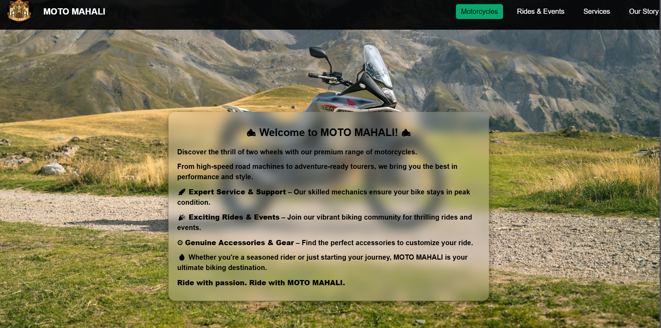

**Motor cycles drop down menu:**

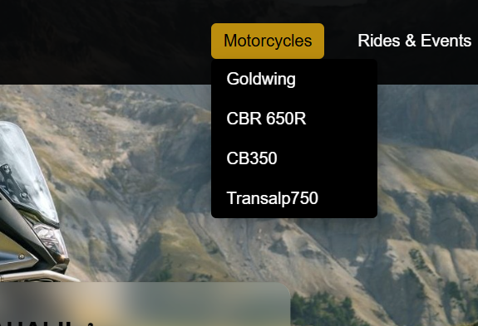

**After clicking a motor cycles [cbr650r]**

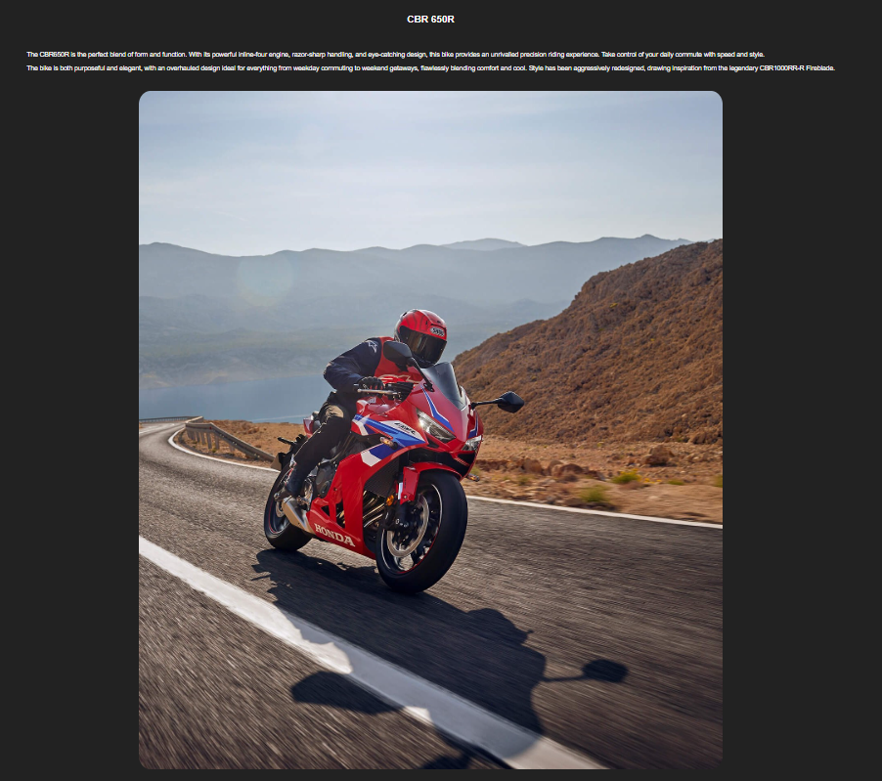

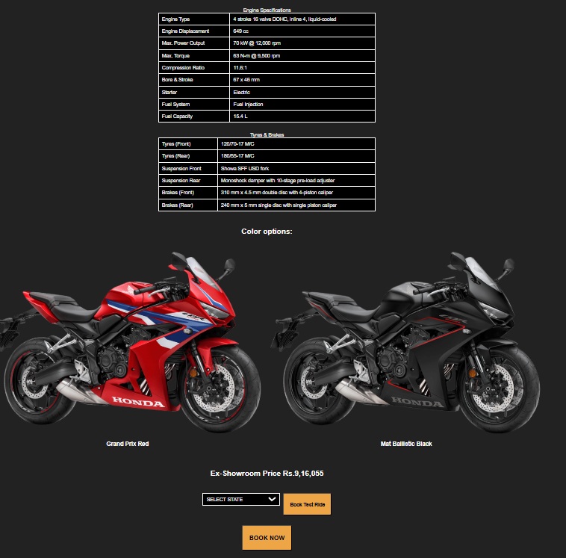

for Goldwing:

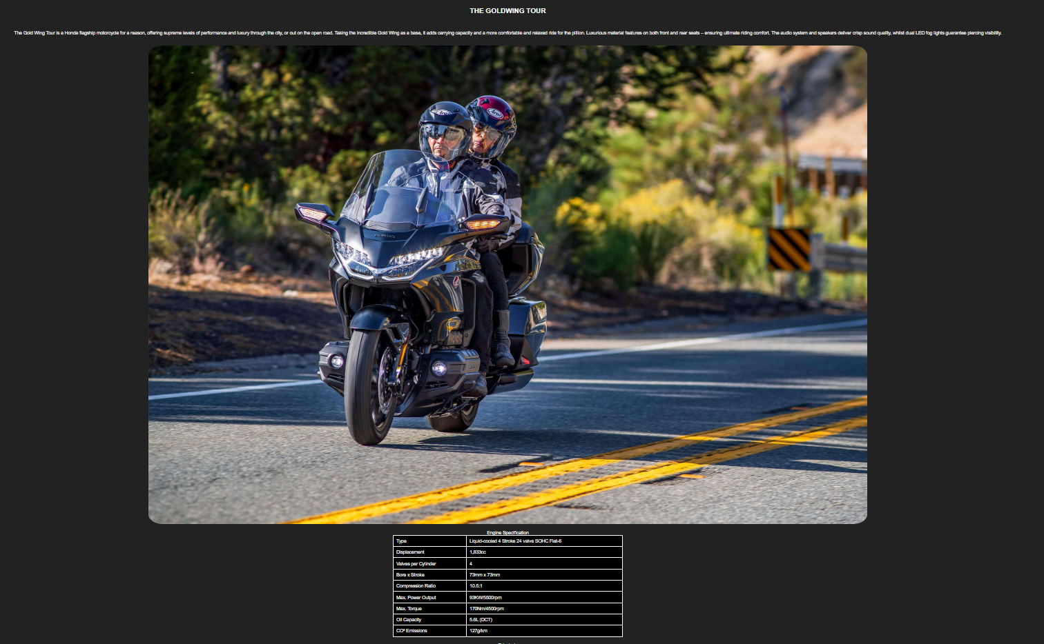

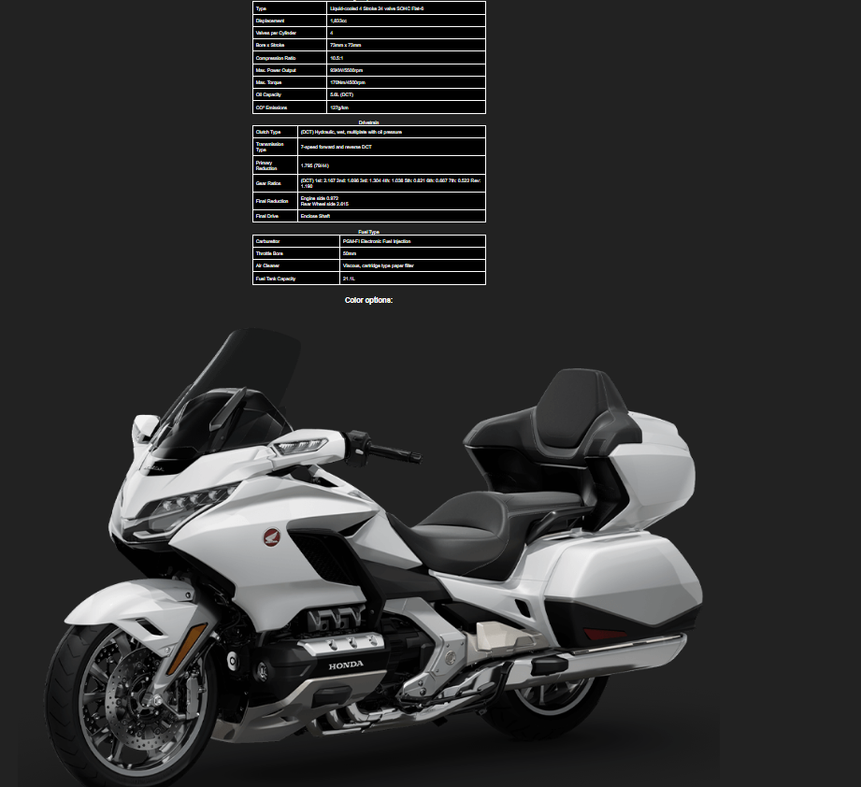

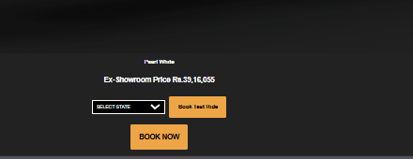

[Other 2 bikes pages will also looks exactly same , only the images will be different]

Service page:

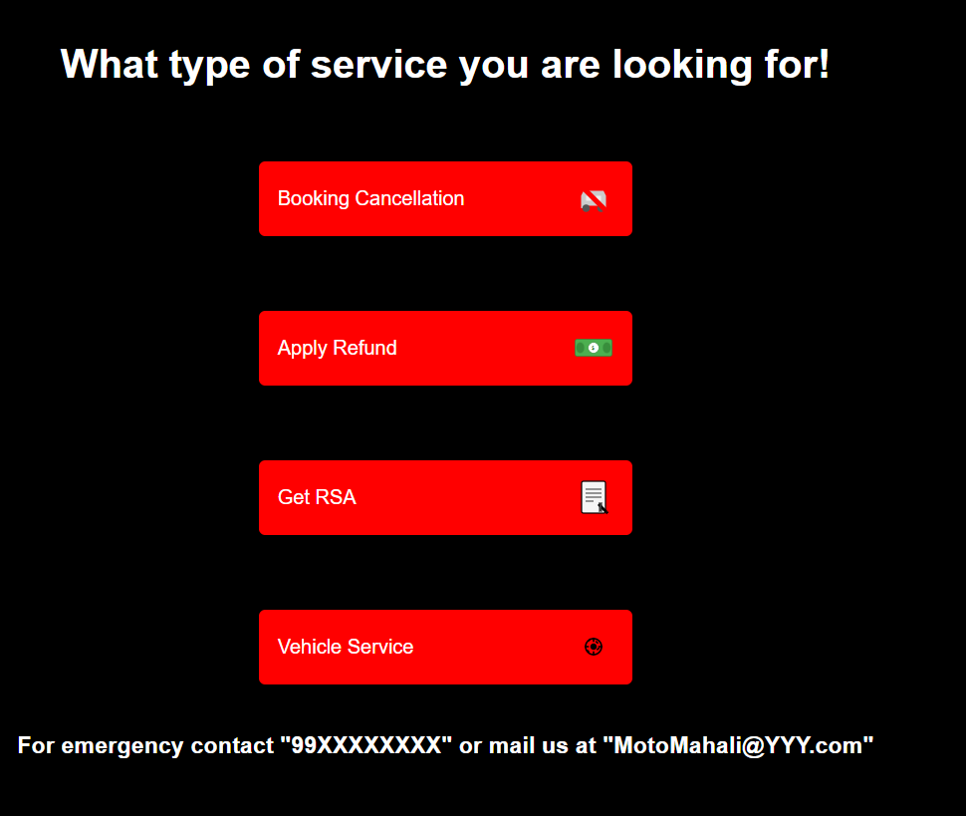

Booking cancellation:

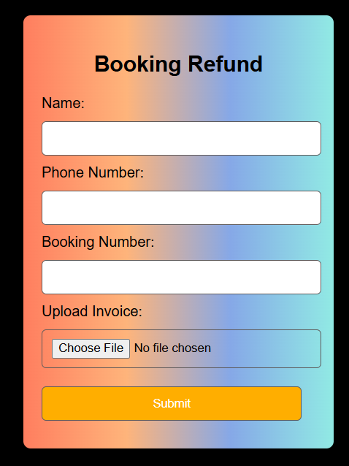

Refund form:

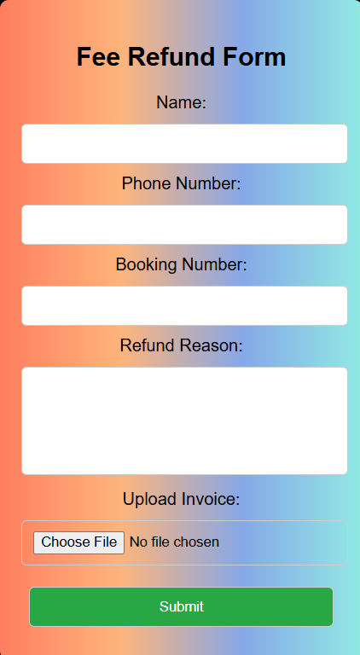

Rc form:

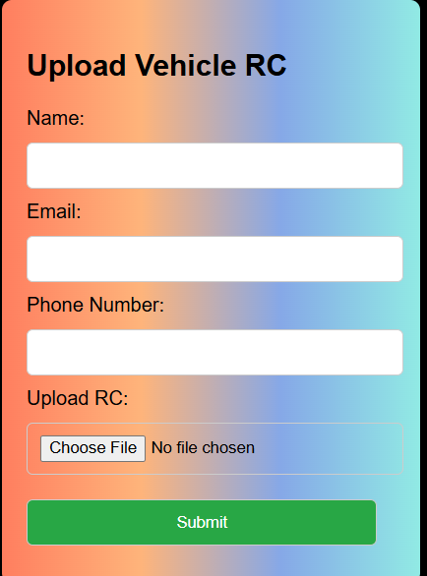

Vehicle service form:

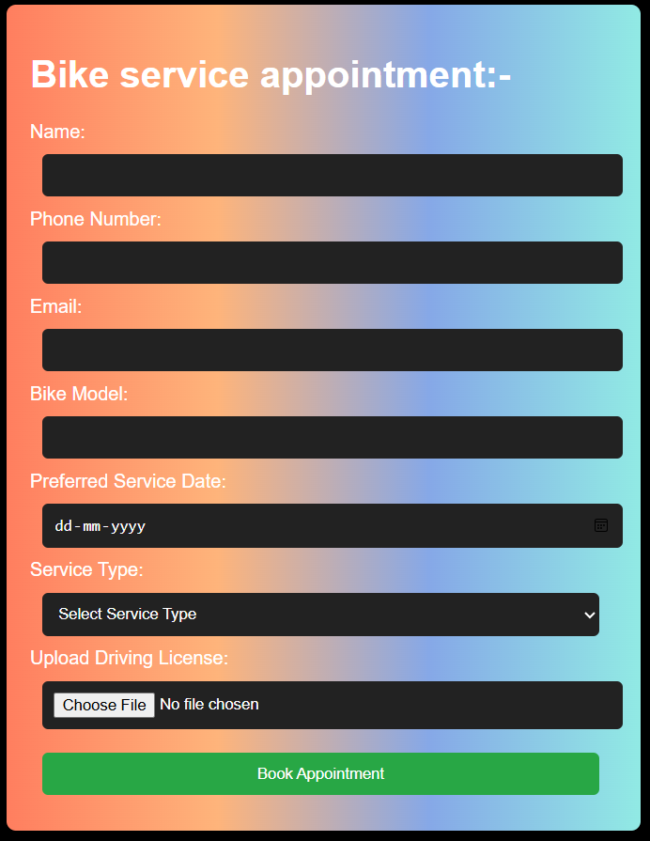

Rides and event page:

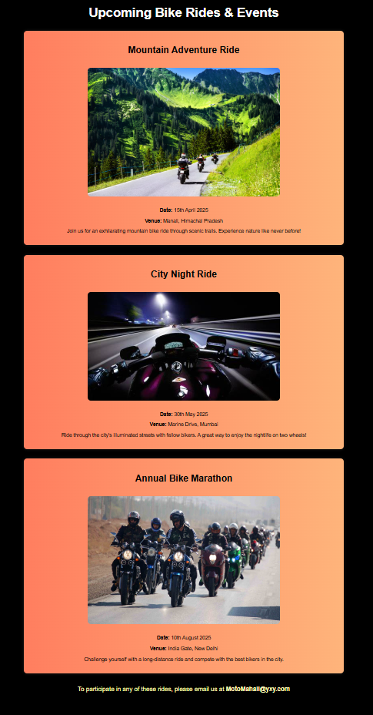

About us page:

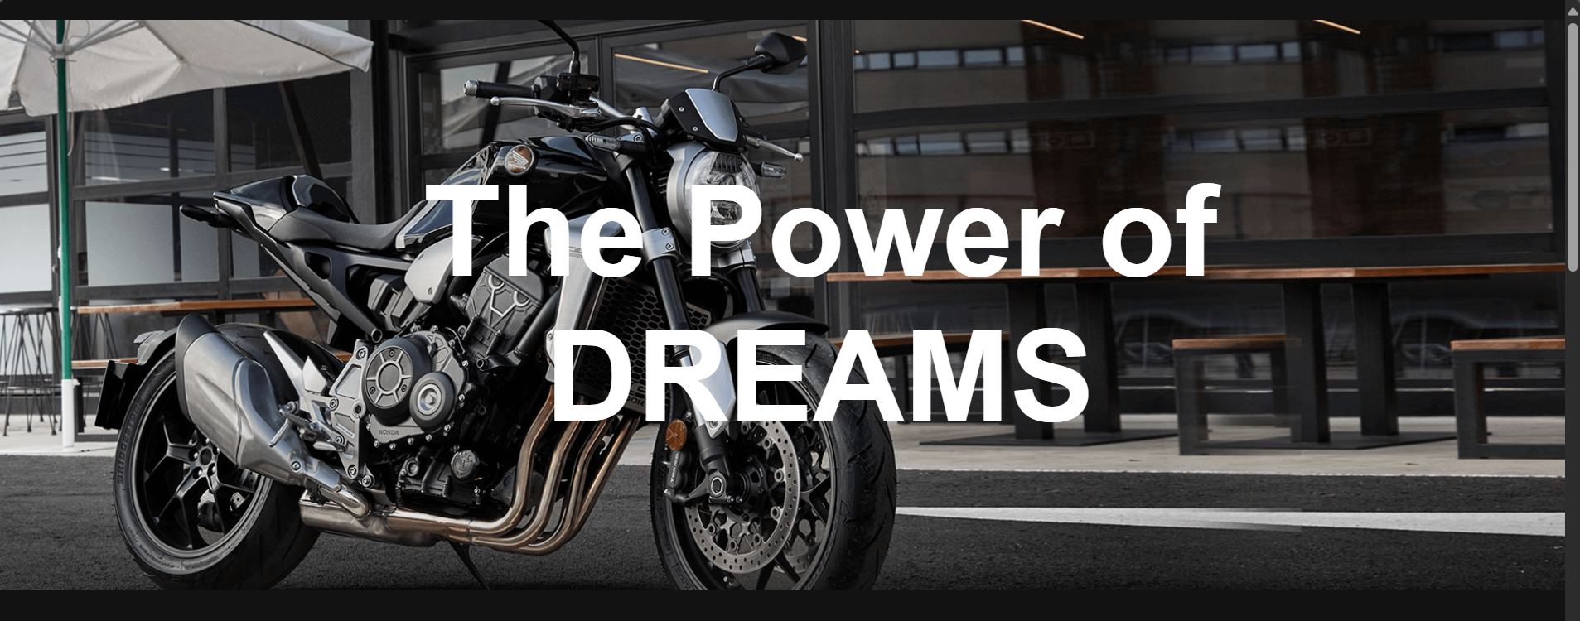

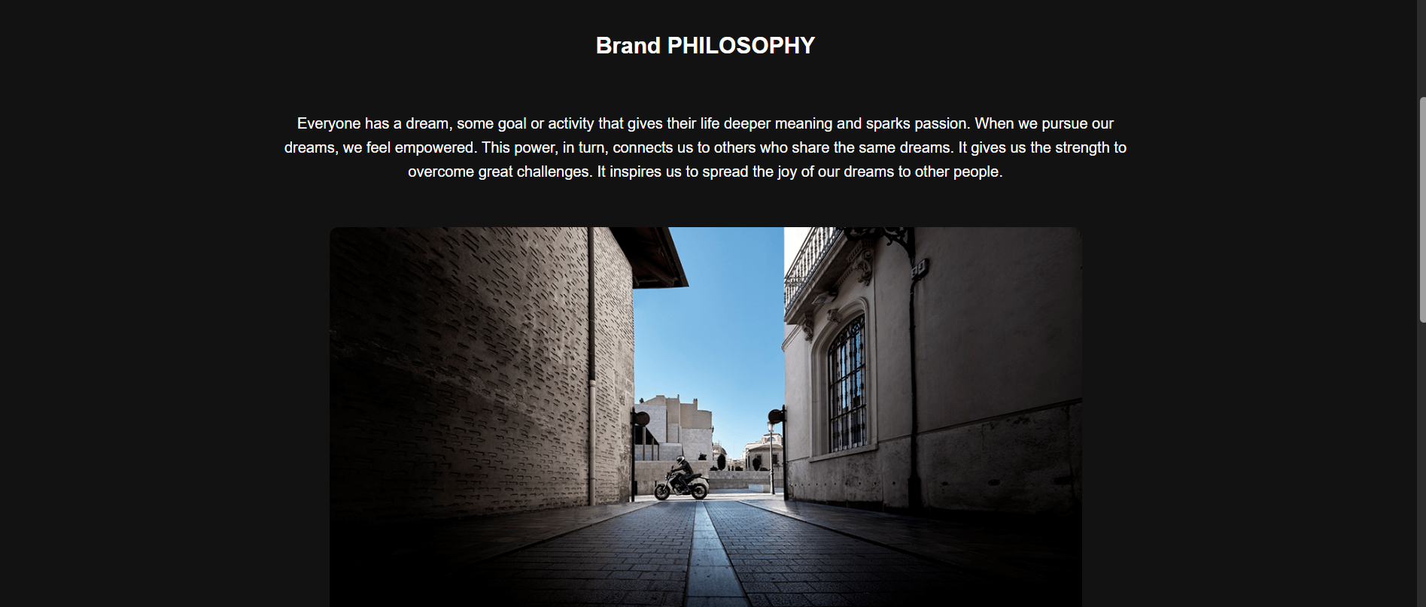

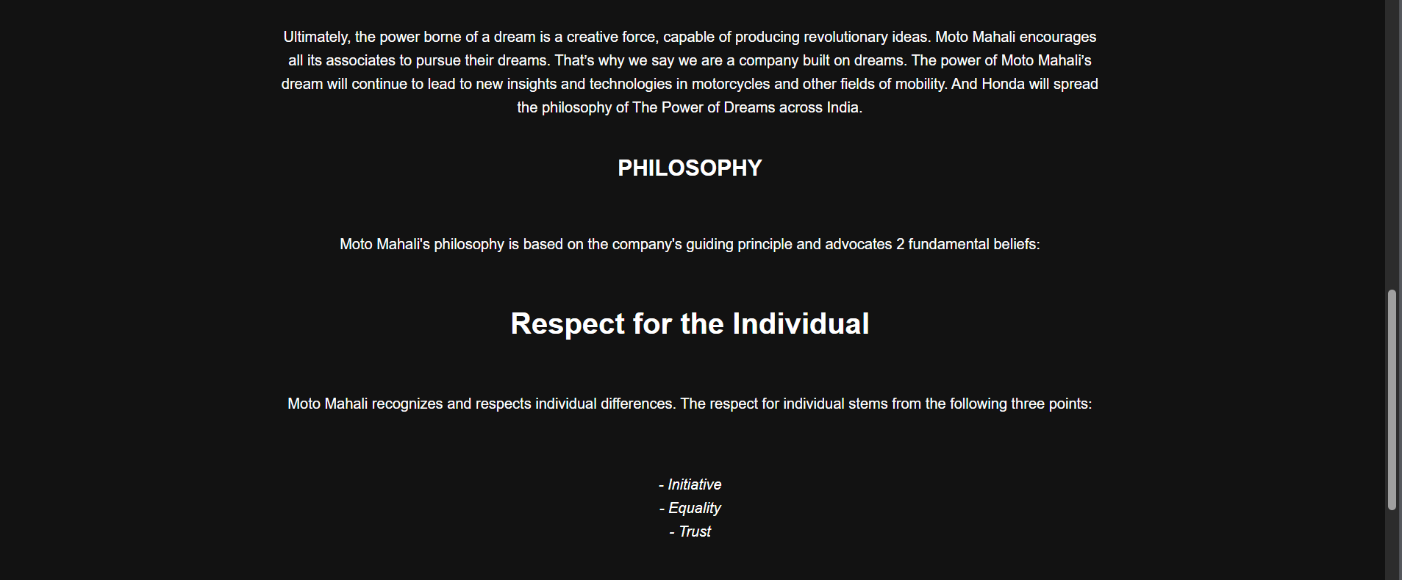

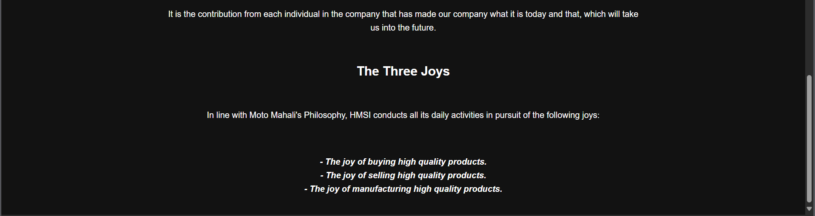

Overview:

I have mainly implemented:

* Tables
* Forms
* Form validation
* svg
* I have also made the webpage responsive making it suitable for mobile screen
* I have also not added any login page since it is just a viewing page and for booking user must use phone number and licence. Also the reference I took for the project was “bigwing india” it is Honda bikes official page which didn’t have a login page.

Result:

This website has been created to provide a comprehensive and engaging platform for showcasing the features, specifications, and booking options of the Honda Goldwing Tour. Designed with user experience in mind, it ensures easy navigation, responsive design for all devices, and quick access to essential information, making it simple for users to explore, learn, and book their dream ride.